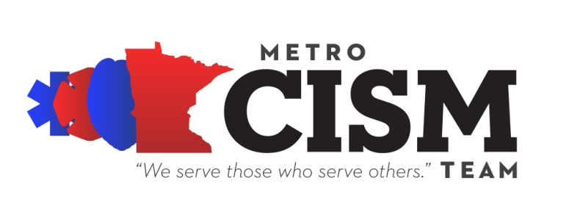
7809 Southtown Center, #174
Bloomington MN 55431-1324
(612) 207-1130

PROTOCOL FOR METRO CISM TEAM SERVICES

TO: Click here to enter text.
PHONE: Click here to enter text.
E-MAIL: Click here to enter text.
FROM: Click here to enter text.
PHONE: Click here to enter text.
DATE: July 6, 2012

The Metro CISM Team will be coming out to the Click here to enter text.. The Team will arrive approximately 30 minutes before the start of the Debriefing at Click here to enter text.. The Group Facilitator may be in contact with you the day before or the day of the group meeting to discuss any specific concerns or questions.

WHAT WILL OCCUR?
Several team members will meet with your responders to provide a forum to discuss the critical incident event that has recently occurred.

These team members are specifically trained police officers, deputy sheriffs, firefighters, EMS professionals and dispatchers from other metro area departments. They will lead a structured discussion about the call. Group facilitators, who are peers but not members of your particular department, often generate more open discussion of critical incident reactions than a discussion with coworkers or commanding officers or supervisors might. The peer leaders will also lead a discussion on typical and atypical critical incident stress responses and healthy ways to cope. A mental health profession or an emergency service chaplain will be part of the team and will provide additional expertise as needed.

Metro CISM Team services are provided at no cost to your department. For more information about The Metro CISM Team, please go to our website at www.metrocism.org or visit us on Facebook.

GUIDELINES: To ensure that the Metro CISM Team services are as effective as possible, please observe the following:

- Group meetings should be held in a location that is private with no interruptions.
- It is highly recommended that participants be out of service for the duration of the meeting, if possible. Meetings typically last 1½-2 hours.
- Mandating attendance at a Metro CISM provided service often backfires, creating resentment and decreasing cooperation. We encourage you to exert strong leadership in support of the meeting instead. Please contact the On-Call Coordinator at 612-207-1130 if you have concerns about this.
- Only those responding to the call, including dispatchers, should participate in the Metro CISM process.
  - It has been our experience that responders are reluctant to speak openly if others, not involved in the call, are in the room. Commanding officers who were not at the scene and coworkers can be most helpful by being available to speak about the incident in the days to follow.
  - Please do not invite private citizens who responded to this call. CISM group meeting are typically not as open if there is an “outsider” in the meeting. Concerns about citizens who assisted with a call can be directed to
612-207-1130.
  - Only responders who were at the scene or dispatchers of the incident should be invited to the debriefing.
- Metro CISM Team group meetings are considered confidential. No records are kept. The Metro CISM Team cannot report what is discussed or how participants are responding to the event to anyone.
- Rank is suspended in Metro CISM group discussions. Responders are often reluctant to discuss their reactions to an event if a commanding officer is in the room, no matter how well like that commander might be. It works best if officers of rank do not attend. Separate, private (1:1) discussions can be arranged for commanding officers that were at the scene and would benefit from processing the event.
- The Metro CISM Team members remain after the group meetings to speak individually with people. Supplying snacks and drinks help responders to feel more comfortable staying later to talk.

Thank you for accessing The Metro CISM Team. You will be contacted several days after The Metro CISM Team has met with your people to evaluate the effectiveness of the intervention and assess whether further services are necessary. In the meantime, please contact me at Click here to enter text. should you have any additional questions or concerns.

