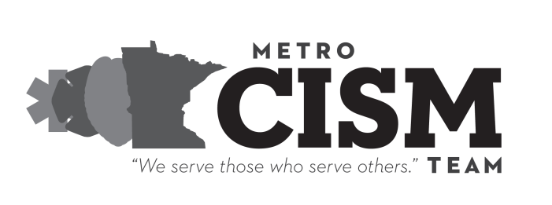
7809 Southtown Center, #174
Bloomington MN 55431-1324
(612) 207-1130
www.metroCISM.org

ROLES & RESPONSIBILITIES - DEBRIEFINGS

MENTAL HEALTH PROFESSIONAL
- The Mental Health Professional (MHP) is responsible for calling the department before the debriefing or the day of the debriefing.
- The MHP is responsible for the Team once onsite. If there is a change in the intervention, the mental health professional, in consultation with the Team, can change the intervention. However, the mental health professional does not lead the intervention!
- The MHP is responsible for convening the pre-intervention team meeting and the post intervention team debrief.
Where do you want to mail these?
- The MHP is responsible to bring all forms necessary for the debriefing, i.e.: Exit Interview, Service Reports, Friends & Family, Critical Incident Information, etc.
- The MHP is responsible for the teaching aspect of the debrief and for listening to “themes” in the debriefing and not a rote script.
- The MHP is responsible for intervening to assist in “righting” group dynamics if they get off course.
- The MHP is responsible for casually evaluating mental status of participants for directing peers to 1-to-1’s if there is a concern about the participant’s mental status and is expected to intervene in any crisis situation that might arise during an intervention.
- The MHP is responsible to send the Service Report and Exit Evaluations to 7809 Southtown Center, #174, Bloomington MN 5543. All reports must be submitted as soon as possible after the event.

PEERS
- Peer team members are responsible for opening the intervention and leading the group through the steps of any given intervention.
- Peer members are responsible for interacting with participants after the intervention, particularly if they want to discuss issues more in depth.
- Peer members are responsible for being a “culture broker” for the mental health professionals, including explaining procedures, jargon, and cultural attitudes of the responders. This is to be done after the intervention, in the privacy of the post intervention debriefing.

SOME THINGS TO REMEMBER
- It is encouraged but not required that the Team members wear their CISM gear to debriefings.
- It is required that team members wear their name identification badge.
- Don’t go to an intervention unless you can give it your full attention! Do not plan to leave immediately after. Please be sure to turn your cell phone off during a debriefing!
- Plan to arrive 30-40 minutes before the intervention. The pre-incident meeting with the Team is very important.
- Plan to have a “debrief” of the Team after the intervention. This is not a tactical or critical review. Encourage each other. Help new members on the Team with examples that might help them to improve their skills. Let this “debrief” be a time where you share how you are feeling about how the debrief went.
- A Team member who is directly or indirectly affiliated with the requesting agency or has a personal relationship with any members of the requesting agency should not respond.

This information is for Team members only and should not be distributed.

